Zoho – Watir, Ruby Exercise

Prepared by


Exercise:

- Build the Watir Scripts for the test case outlined below including all the validations
- Build a reporting interface that displays the report outlined in the ‘Reporting’ section
- Put together a 1-page document outlining the technical specifications and architecture of your solution
- Deliver the final deliverable as a zip file with basic instructions on how to run the application.

Test Case:

- Login @ http://crm.zoho.com/crm/login.sas - login/pwd : joeklienwair@gmail.com/watir001

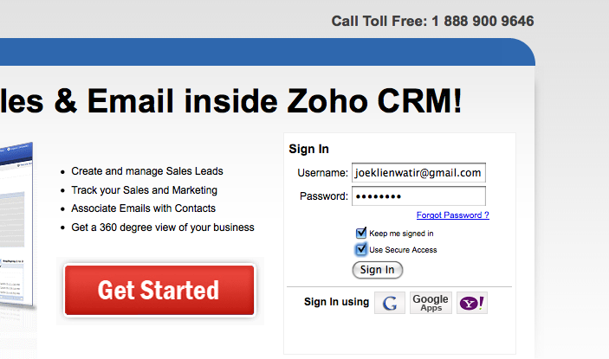
- Click “New Account” 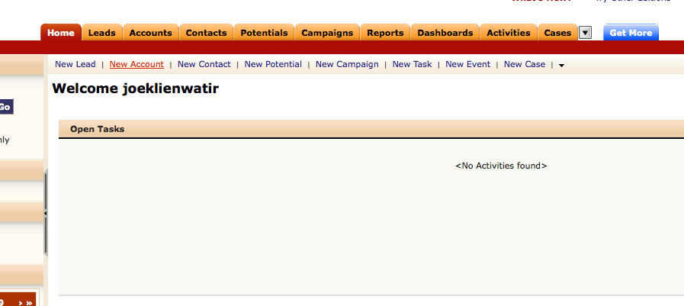
- Add the following details:
  - Account Name (Test Account #XX)
  - Phone Number
  - Click the icon next to ‘Parent Account’ – from the pop-up select ‘Parent Account’ by clicking on it
  - Account Type (Dropdown – select Analyst)
  - Industry Dropdown – select ASP
  - Address Information – populate all the fields
- Click ‘Copy Address’ button – in the drop down select – ‘Billing to Shipping’
- In the description – write – ‘This is a test description’
- Your inputs should end up looking like this: 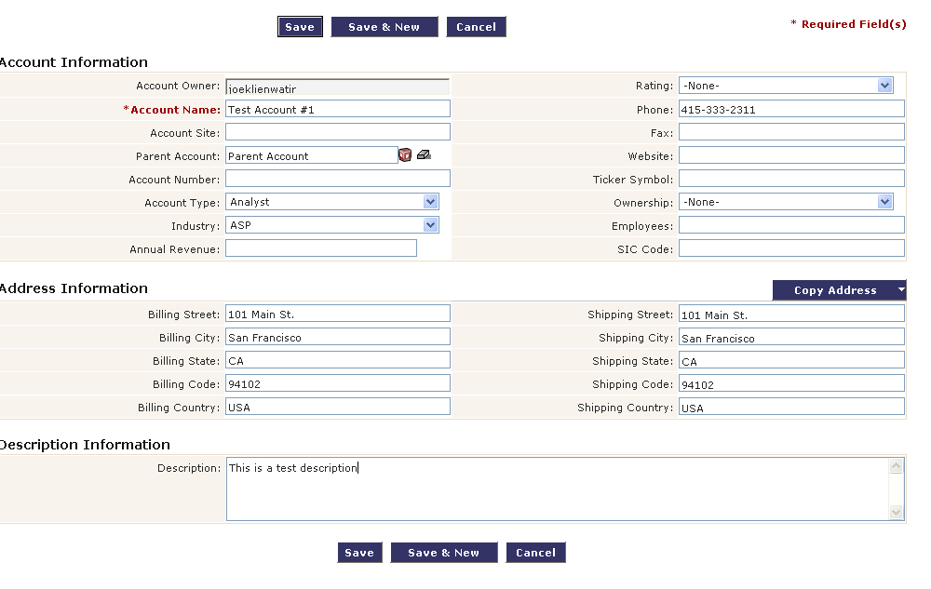
- Click on the ‘Accounts’ Tab
- Click the Account Name you just created
- Validate that all the inputs you made are saved on this page: 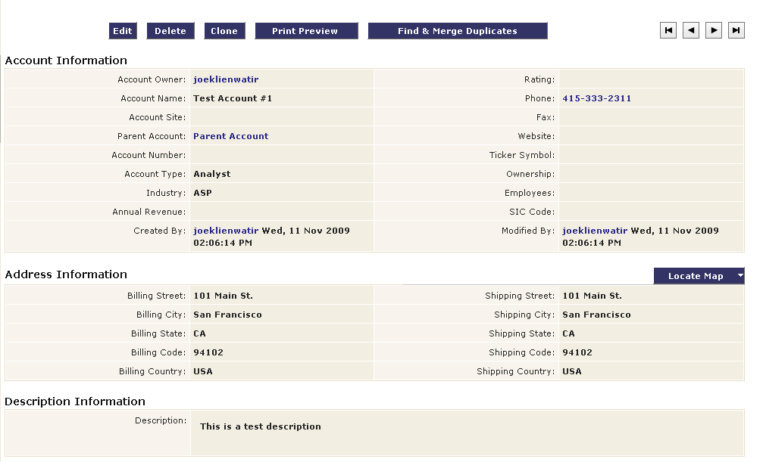
- Click ‘New Account’ in the header
- On a blank page (without any inputs) click ‘Save’
- Validate that a modal window pops up saying ‘Account Name cannot be empty’ 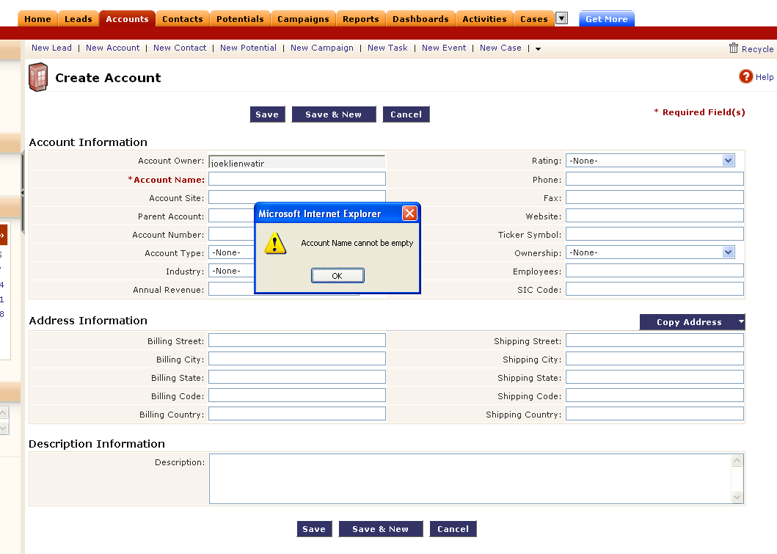
- Click ‘Setup’ in the top right corner of the screen
- From the advanced section – click on the ‘Export Data’ option
- From the drop down select – ‘export accounts’
- Click ‘Export’ button
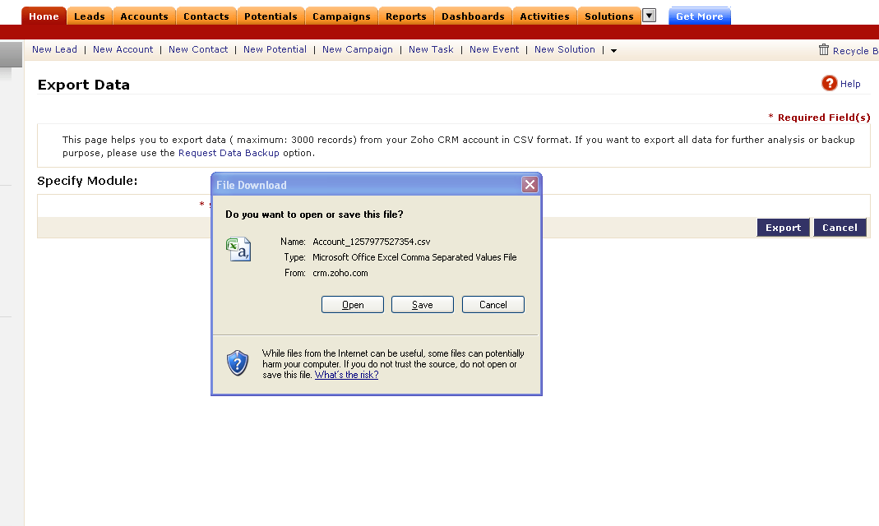

- Validate that a ‘File Download’ window pops-up
- Click ‘Save’ 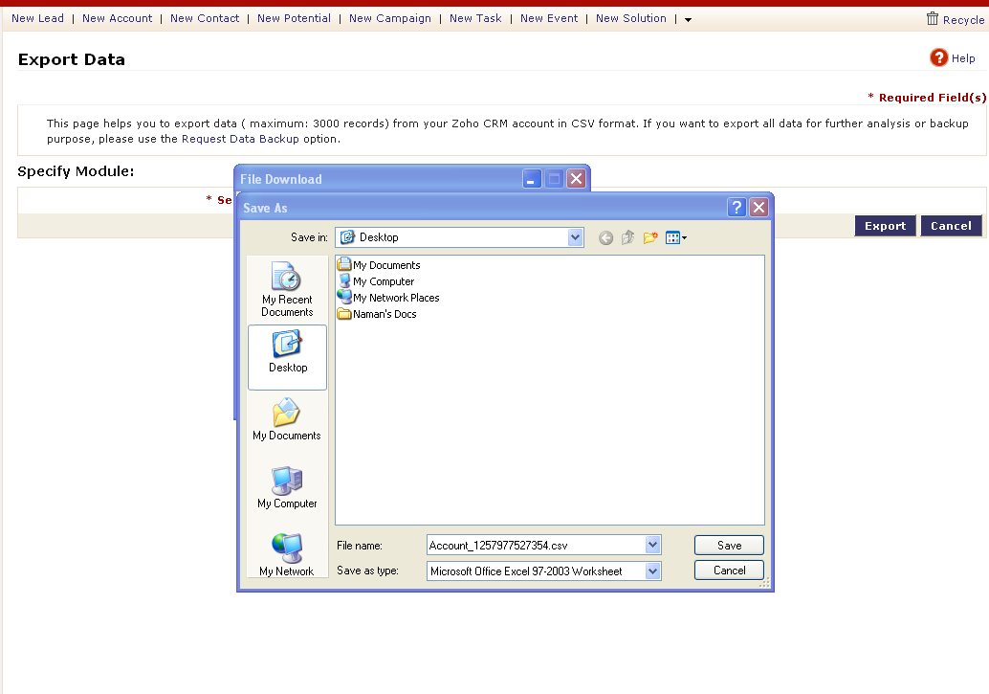
- Click ‘Save’ in the ensuing ‘Save As’ window
- Click ‘Close’ in the ‘Download Complete’ pop-up window
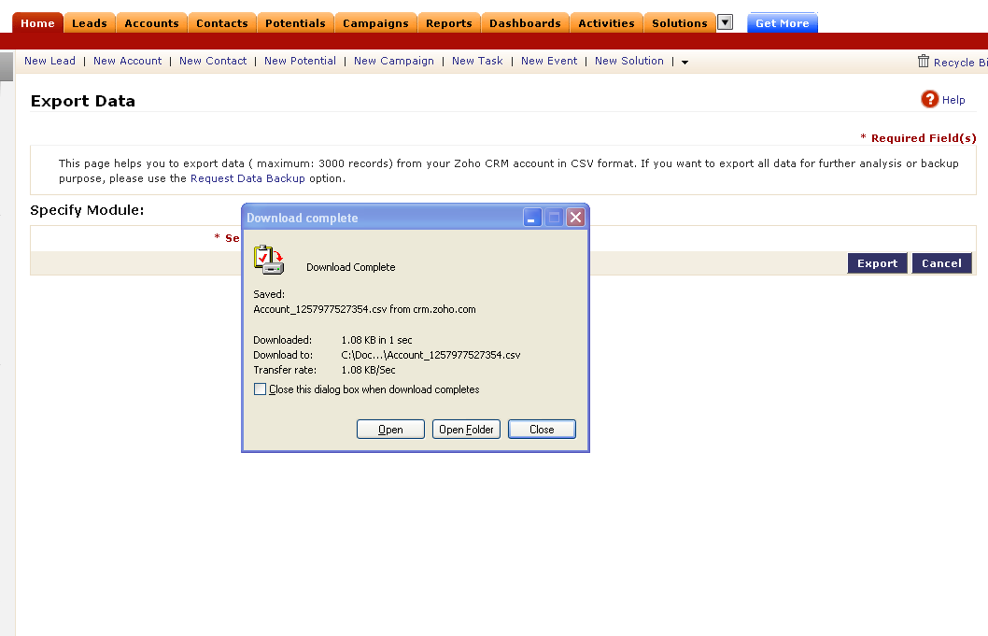

- Click on the “Accounts” Tab
- Click on “Import my accounts” from the ‘Account Tools’ 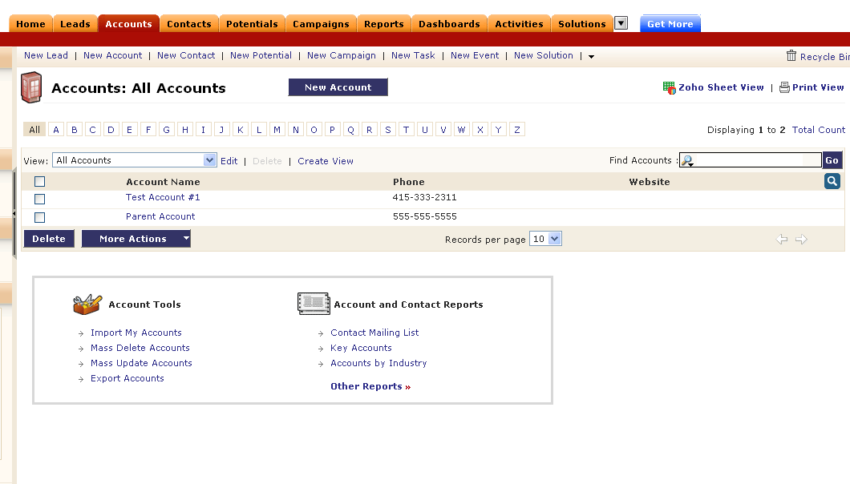
- From the ‘Import my accounts Wizard’ click browse and select the file you just saved in Steps # 17-20 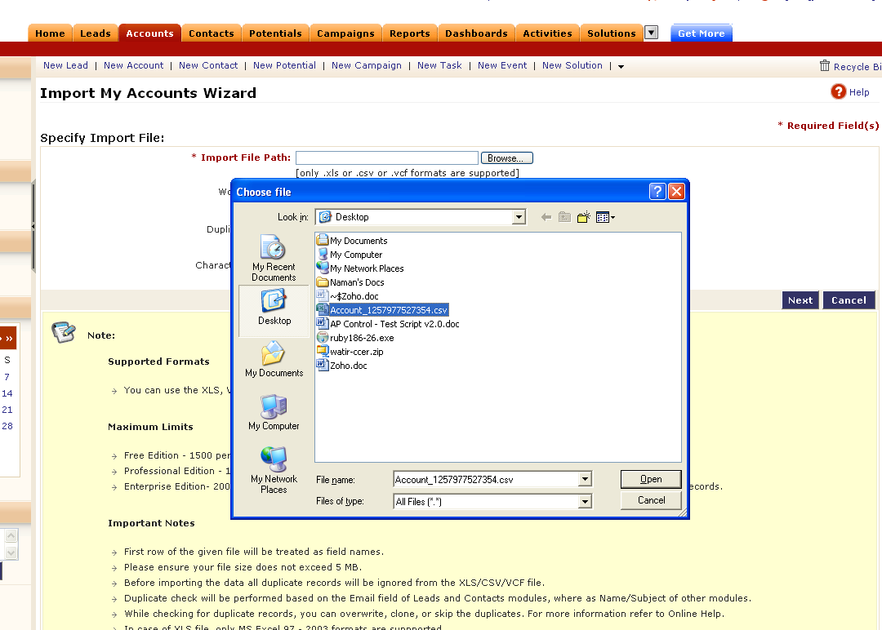
- Click ‘Next’
- On the next screen of the wizard – select ‘Account Name’ from the drop down alongside the ‘Account Name’ and click ‘Next’ 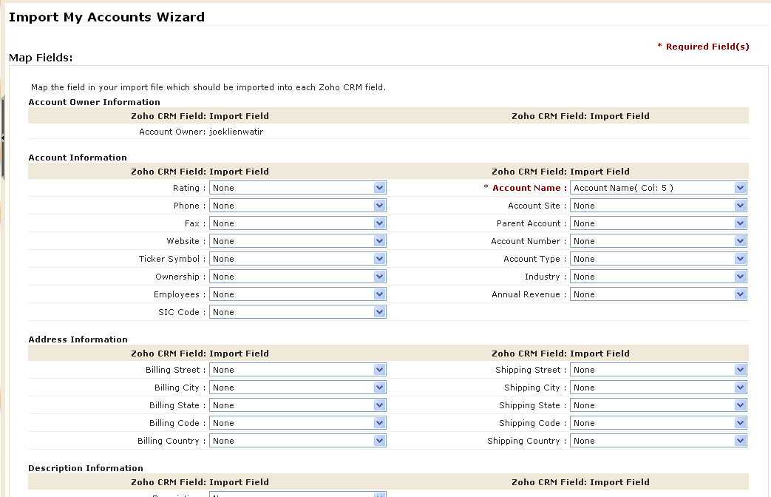
- On the next screen click ‘Import’ 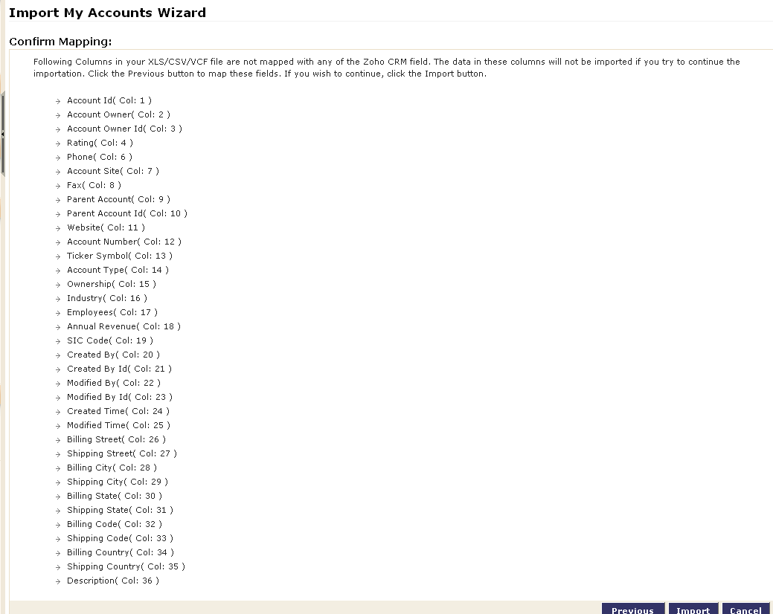
- On the next screen – validate that the No. of records added has a non-zero value associated with it.

Validations:

- For each page you hit we want to validate that each click resulted in a successful page load and no errors
  - Login page: http://crm.zoho.com/crm/login.sas
  - Home Page - http://crm.zoho.com/crm/ShowHomePage.do
  - Etc
- On New Account creation – we want to validate that all inputs we specified were saved correctly (think about how you’ll incorporate the ‘Copy Address’ function on the create new account page)
- On the New Account creation – we want to validate that submitting a form without the required fields results in an error message pop-up modal window
- On the Export File section –we want to validate that a file was successfully downloaded to the desktop by verifying the various windows pop-ups are displayed in order.
- On the Import file data – we want to validate that a file was successfully imported into the system by verifying that the No. of records added has a non-zero value associated with it.

Reporting:

We need to generate an HTML report that looks something like this (with better UI):

Results:
- # of Items tested: 30
- Time taken to run: 150 seconds
- Details:

URL | Action | Result
http://crm.zoho.com/crm/login.sas | ‘Submit’ Button | Successful
http://crm.zoho.com/crm/ShowHomePage.do | ‘New Account’ Link | Successful
http://crm.zoho.com/crm/ShowHomePage.do | ‘Copy Address’ Button | Successful
http://crm.zoho.com/crm/ShowHomePage.do | ‘Save’ Button | Successful
http://crm.zoho.com/crm/ShowHomePage.do | Validate Data saved correctly | Successful

